
Department of Mechanical Engineering

EMCH 368
MECHATRONICS

Lab 09
Fundamentals of Machine Learning

Last Edited: 3/13/2024 by J. Vaught

#1 Fundamentals of Regression
Machine learning stands as a beacon of progress in the digital age, offering new ways to analyze patterns, make predictions, and understand our world. Central to machine learning is regression analysis—a statistical method used for modeling and analyzing the relationships between variables. This short summary delves into the intricacies of regression, starting with linear regression and expanding to more complex forms.

Section 1: Linear Regression
History and Importance
Linear regression, the oldest and most straightforward type of regression, traces its roots back to the 19th century with the work of Francis Galton. Galton used the method to describe biological phenomena, coining the term "regression" from the concept that traits of descendants (e.g., height) regress, or fall back, towards a mean or average over generations.

Notation and Formula
The equation for a simple linear regression line is given by:
$$Y=β_{0}+β_{1}X+ε$$
where:
- $Y$ is the dependent variable (the variable we are trying to predict).
- $X$ is the independent variable (the variable we use to make predictions).
- $β_{0}$ is the y-intercept of the regression line.
- $β_{1}$ is the slope of the regression line, indicating how much Y changes for a one-unit change in X.
- $ε$ represents the error term

Computer Usage
In MATLAB, `polyfit(X, Y, 1)` fits a first-degree polynomial (linear model) to data:
- `X` is the independent variable vector.
- `Y` is the dependent variable vector.
- The function returns coefficients `p` of the best-fit line.

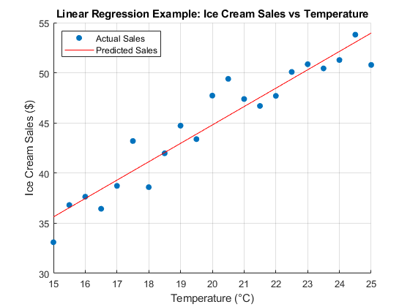
Simple Example
Imagine a researcher studying the relationship between temperature and ice cream sales. In this scenario, the number of ice creams sold (Y) increases linearly with the day's temperature (X). By collecting data on sales and temperature, the researcher could use linear regression to predict sales on a given day based on the temperature.

Section 2: Multiple Regression
History and Importance
Multiple regression extends linear regression to more than one independent variable, offering a more nuanced view of complex relationships. This method became more prevalent as computational resources increased, allowing for the analysis of multiple variables simultaneously.

Mathematical Derivation
The derivation of multiple regression coefficients also uses the least squares method but in a higher-dimensional space. Each coefficient represents the partial effect of one independent variable on the dependent variable, holding all other variables constant.

Notation and Formula
The multiple regression equation is:
$$Y=β_{0}+β_{1}X_{1}+β_{2}X_{2}+…+β_{n}X_{n}+ε$$
Here, $X_{1},X_{2},…,X_{n}$ represent different independent variables, and $β_{1},β_{2},…,β_{n}$ are the corresponding coefficients.

Computer Usage
In MATLAB, `regress(Y, X)` performs linear regression:
- `Y` is the outcome vector.
- `X` is the predictor matrix.
- The function returns the best-fit coefficients.

Simple Example
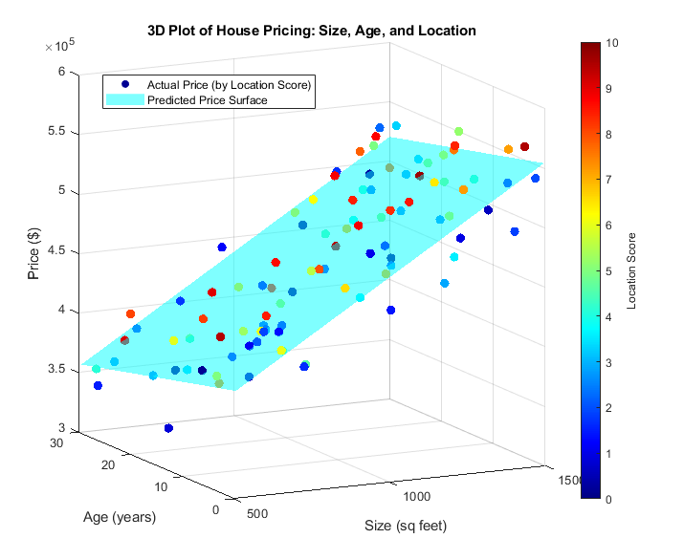
Consider a real estate analyst trying to predict the price of houses (Y) based on their size (X1), age (X2), and location (X3). By applying multiple regression, the analyst could determine how each factor affects house prices independently and together.

Section 3: Polynomial Regression
History and Importance
Polynomial regression generalizes linear regression to account for non-linear relationships between the dependent and independent variables. While still based on the principles established by Galton and others, it provides a more flexible curve fitting than linear models.

Mathematical Derivation
Polynomial regression fits a polynomial equation to the data points instead of a straight line. The least squares method is again employed to find the coefficients that minimize the error between the predicted and actual values.

Notation and Formula
The formula for a polynomial regression of degree n is:
$$Y=β_{0}+β_{1}X+β_{2}X^{2}+…+β_{n}X^{n}+ε$$
where $X$ is the independent variable and $β_{0},β_{1},…,β_{n}$are the coefficients of the model.

Computer Usage
Either polyfit(X,Y,2) would suffice for this problem. (Look at examples 1 for usage). The ‘2’ indicates a 2nd order polynomial.

Simple Example
A biologist studying the growth rate of bacteria at different temperatures may find that the relationship is not linear but follows a quadratic curve. Polynomial regression could then be used to model this relationship and predict growth at untested temperatures.
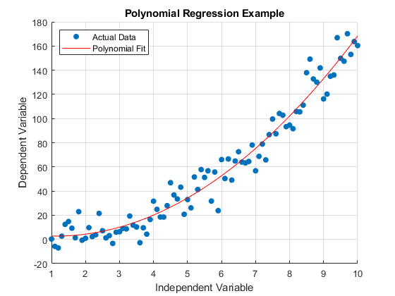

Section 4: Logistic Regression
History and Importance
Logistic regression, developed in the 20th century, diverges from other types by focusing on binary outcomes—situations where the dependent variable has only two possible values. It's widely used in fields like medicine and economics for classification tasks.

Mathematical Derivation
Logistic regression uses the logistic function to model the probability that a given instance falls into a particular category. The coefficients are estimated using maximum likelihood estimation, a method that finds the values that make the observed outcomes most likely.

Notation and Formula
The logistic regression model is expressed as:
$$P\left(Y=1\right)=\frac{1}{1+e^{-\left(β_{0}+β_{1}X\right)}}$$
where $P\left(Y=1\right)$ is the probability that the dependent variable is 1 (or 'true').

Computer Usage
The b = glmfit(X, y, dist) command in MATLAB is used to fit generalized linear models (GLMs) to data.
- `X`: Design matrix of predictors with size `n` by `p`, where `n` is the number of observations and `p` is the number of predictors. Include a column of ones to include an intercept in the model.
- `y`: Response vector with size `n` by 1.
- `dist`: A string specifying the distribution of the response variable (e.g., 'normal', 'binomial', 'poisson').

Simple Example
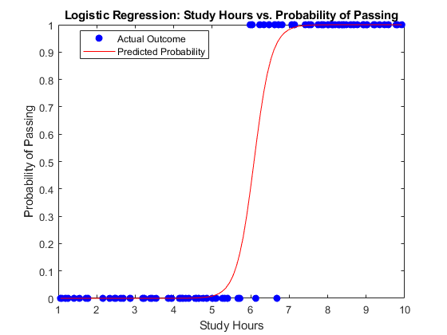
We can use logistic regression to predict whether a student passes or fails an exam based on their study hours. In this case, the outcome (pass or fail) is binary, making it suitable for logistic regression.

#2 Introduction to Decision Trees and Random Forests
Section 1: Decision Trees
Definitions
Decision Trees are a type of supervised machine learning algorithm that is used for both classification and regression tasks. They are called "trees" because they take the form of a tree structure. In this structure, each internal node represents a "test" or "decision" on an attribute of the data, each branch represents the outcome of that test, and each leaf node represents a class label (in classification) or a continuous value (in regression).
The topmost node in a tree is known as the root node. It learns to partition based on the attribute value. It splits the data into two or more homogeneous sets (or subsets) based on the most significant splitter/differentiator in input variables.

Process of Building Trees
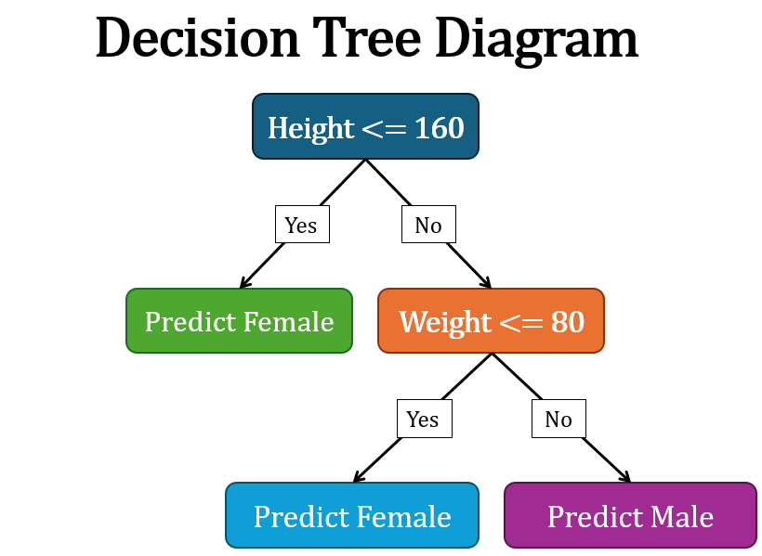
Decision trees are built using a process known as recursive partitioning. This process starts at the root node and splits the data on the feature that results in the most significant information gain (IG) or the greatest decrease in impurity (Gini impurity, entropy). This is done recursively for each branch, partitioning the data until one of the termination conditions is met:
- All the instances belong to a single value of the target variable (pure leaf).
- No more significant attributes are left to partition the data.
- The depth of the tree reaches a predefined limit.
In the tree, decision nodes are used to make a decision and split the data, while leaf nodes represent the outcome of those decisions or the final outputs.

Advantages:
- Interpretability: Trees can be visualized, making them easy to understand and interpret. They mimic human decision-making more closely than other algorithms, which can make them particularly useful in business settings.
- No need for feature scaling: Decision trees do not require normalization or standardization of features, as they do not depend on the scale of features.
- Handling both numerical and categorical data: Trees can handle data involving both numeric and categorical variables without needing dummy variables or one-hot encoding.

Limitations:
- Overfitting: Without proper constraints or pruning, decision trees can create overly complex trees that do not generalize well to new data. They can become too tailored to the training data, capturing noise along with the underlying patterns.
- Instability: Small changes in the data can lead to very different tree structures. This instability is due to the hierarchical nature of decision trees, where errors at the top level propagate down the entire tree.
- Biased with imbalanced data: If some classes dominate, decision trees can create biased trees, so it is often recommended to balance the dataset before creating the tree.

Section 2: Ensemble Learning and Random Forests
Basics of Ensemble Learning
Ensemble learning is a machine learning paradigm where multiple models (often called "learners" or "base models") are trained to solve the same problem and combined to get better results. The main principle behind ensemble learning is that a group of weak learners can come together to form a strong learner. This approach improves the prediction, stability, and accuracy of the model.

There are various ensemble learning techniques, but they can broadly be classified into two types:
- Bagging (Bootstrap Aggregating): Multiple learners are trained in parallel with different subsets of the training data (obtained by bootstrapping, which involves random sampling with replacement). Their predictions are then aggregated (for example, by averaging) to form the final prediction. Random forests are an extension of this approach.
- Boosting: Learners are trained sequentially, each trying to correct its predecessor. The final prediction is made based on a weighted sum of all learners. Examples include AdaBoost and Gradient Boosting.

Introduction to Random Forests
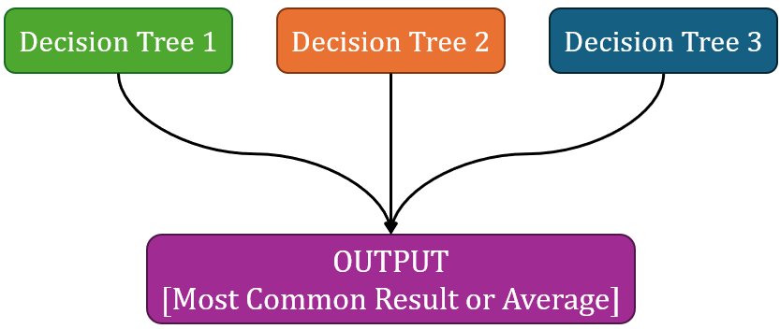
Random Forests are an ensemble learning technique that builds off the concept of decision trees. A Random Forest consists of a large number of individual decision trees that operate as an ensemble. Each tree in the random forest spits out a class prediction, and the class with the most votes becomes the model’s prediction.
The fundamental concept behind random forests is the idea that a combination of learning models increases the overall result. Put simply: random forests build multiple decision trees and merge them together to get a more accurate and stable prediction.

Training Individual Trees
Each tree in a Random Forest is built from a sample drawn with replacement, known as bootstrap sampling, from the training set. Additionally, when constructing trees, Random Forests use a random subset of the features at each split decision in the tree-building process, which adds to the diversity among the trees and results in a more robust overall model.

Combining Trees in a Forest
In Random Forests, the ensemble's final prediction is typically made by majority vote (for classification tasks) or by averaging the predictions (for regression tasks). This process helps to reduce the variance, and thus overfitting, compared to individual decision trees, as the various errors of individual trees can cancel each other out.

Feature Importance in Random Forests
One of the useful byproducts of random forests is the ability to evaluate the importance of different features in making predictions. This is typically measured by looking at how much each feature decreases the purity of the node (measured by Gini impurity or entropy) averaged over all trees in the forest. In essence, the more an attribute reduces the impurity, the more important it is. This feature importance metric can be used for feature selection or to gain insights into the dataset.

Gini Impurity
Gini impurity is a measure used in decision trees and random forests to quantify how often a randomly chosen element from the set would be incorrectly labeled if it was randomly labeled according to the distribution of labels in the subset. It ranges from 0 to 0.5, where 0 indicates that all elements belong to a single class (perfect purity), and 0.5 means that the elements are distributed evenly across different classes (maximum impurity).
The Gini Impurity of a dataset is calculated as follows:
$$Gini=1-\sum_{i=1}^{n}{{\left(p_{i}\right)}^{2}}$$
where $p_{i}$ is the proportion of items labeled with class i in the set.
In the context of decision trees, during each split, the feature and value that result in the lowest Gini impurity are chosen for the node split. Lower Gini impurity is better as it indicates a higher purity of nodes, meaning the groups resulting from the split contain predominantly instances of a single class.

Entropy
Entropy is another measure used to quantify the impurity or disorder within a set. It originates from information theory and measures the level of uncertainty or unpredictability in the data. In the context of decision trees, entropy is used as a criterion for splitting the data. High entropy means that the information is very diverse (high variability or disorder), whereas low entropy means that the information is more uniform (low variability).
The entropy of a dataset is defined as:
$$Entropy=-\sum_{i=1}^{n}{p_{i}}\log_{2}\left(p_{i}\right)$$
where $p_{i}$ is the proportion of items labeled with class i in the set.
When building a decision tree, the feature and split point that achieve the greatest reduction in entropy (greatest increase in information gain) are chosen for the split. Essentially, the goal is to decrease uncertainty (entropy) after each split, leading to more homogenous nodes.

Section 3: Data Representation with Embeddings
Introduction to Embeddings
Embeddings are a form of data representation that converts complex objects such as words, sentences, or entire documents, as well as images and other types of high-dimensional data, into vectors of real numbers. This technique is fundamental in machine learning and deep learning, where the model needs a numerical representation of data to perform tasks such as classification, clustering, or prediction.
The main goal of embeddings is to capture the contextual meanings, relationships, and semantics of the input data in a dense, low-dimensional space. This contrasts with sparse representations like one-hot encoding, where the context and relationships between different data points are not effectively captured.
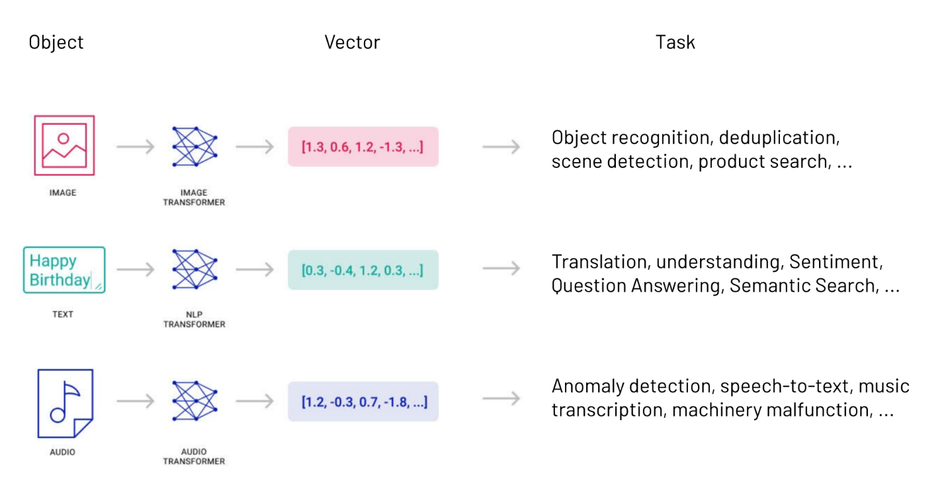
Properties of Embeddings
A good embedding captures the inherent properties of the input data, such as similarities or relationships. For example, in word embeddings, semantically similar words should be close to each other in the embedding space. This is often visualized by using techniques like t-SNE or PCA, where related words cluster together.
Embeddings should also reduce dimensionality while retaining as much of the original data's variance or information as possible. This makes embeddings extremely useful for handling high-dimensional data, reducing computational load, and improving model performance.

Applications of Embeddings
- Natural Language Processing (NLP): In NLP, embeddings are used to represent words or phrases for tasks such as sentiment analysis, text classification, and machine translation. Word2Vec, GloVe, and BERT are examples of models used to create word embeddings.
- Image Processing: Embeddings can represent images for tasks like image recognition, classification, and similarity searches. Convolutional neural networks often produce such embeddings.
- Recommendation Systems: Embeddings can represent users and items (like movies or products) to predict user preferences and suggest items similar to those a user likes.
- Graph Data: Nodes in a graph (like social networks or knowledge graphs) can be embedded to capture their relationships and interactions for tasks such as link prediction or community detection.

Generating Embeddings
Generating embeddings involves training a model on a specific task, such as predicting the next word in a sentence (for word embeddings) or identifying objects within an image. Through this training process, the model learns to map the input data into a dense vector space.
The dimensions of this vector space are typically much lower than the original input space, but they capture significant information about the input. For example, in the case of word embeddings, each dimension might capture grammatical, syntactic, or semantic aspects of the words.

Section 4: Model Evaluation and Optimization
Introduction to Model Evaluation
Model evaluation is a crucial step in the machine learning workflow. It helps in understanding the performance of a model and in determining how well it will generalize to unseen data. Effective model evaluation ensures that the selected model solves the given problem most effectively and efficiently.
The evaluation involves using specific metrics and methodologies, depending on the type of machine learning task (e.g., classification, regression, clustering). Common metrics include accuracy, precision, recall, F1 score for classification tasks, and mean squared error, mean absolute error, and R² for regression tasks.

Out-of-Bag (OOB) Error
Out-of-Bag (OOB) error is a unique model evaluation method used specifically with ensemble methods like Random Forests. Each tree in a Random Forest is trained on a different subset of the data, created by bootstrapping (sampling with replacement). Approximately one-third of the cases are left out of the bootstrap sample and not used to train a given tree. These left-out samples can be used to evaluate the tree's performance; this is known as the OOB error.
The OOB error is the average error for each calculation using just the trees that were not trained with that specific instance. In Random Forests, the OOB error estimate is as accurate as using a test set of the same size as the training set. Therefore, it is an efficient method of model evaluation, eliminating the need for a separate validation or test set.

Learning Curves and the Number of Trees
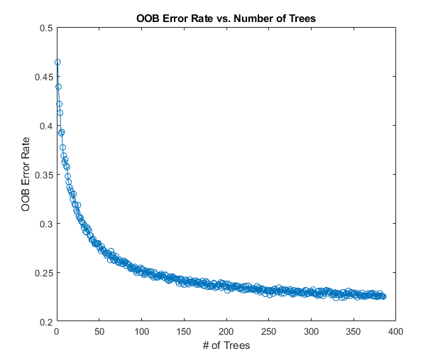
A learning curve is a plot that shows the relationship between the training and validation errors versus experience (such as the number of trees in a Random Forest or the number of training epochs in neural network training). It is a tool to diagnose the bias-variance trade-off and to understand the behavior of the model as it learns.
As the number of trees in a Random Forest increases, the model's ability to fit the data improves, leading to a decrease in bias and training error. However, after a certain number of trees, improvements become marginal, and the curve levels off; this is due to the law of diminishing returns. Moreover, if the number of trees is too high, it might lead to excessive computational cost without significant improvement in performance. The point where the learning curve starts to plateau can indicate the optimal number of trees, beyond which increasing the number does not significantly improve the model's out-of-bag error.

Bias-Variance Tradeoff
The bias-variance tradeoff is a fundamental concept in machine learning that describes the tension between the error introduced by the model's assumptions (bias) and the error introduced by the model's sensitivity to the training set (variance).
- High bias models make strong assumptions about the form of the underlying function that generates the data. They may oversimplify the model, leading to errors in training and testing data (underfitting).
- High variance models are highly sensitive to the training data and can capture noise as if it were a real signal, leading them to perform poorly on new, unseen data (overfitting).
The goal in machine learning is to find a good balance between bias and variance, minimizing total error. This often involves choosing the right model complexity or the correct regularization techniques to prevent overfitting while maintaining the model's ability to capture underlying patterns.

#3 Introduction to FNNs and Image Classification
Section 1: Fundamentals of Neural Networks
Neural networks represent an intriguing paradigm in computational intelligence, reflecting the attempt to mimic biological neural systems' operations. Originating from the desire to understand human brain processes and emulate its efficiency, neural networks have evolved into a crucial tool in machine learning and artificial intelligence. They consist of units, known as neurons, connected together to form a network capable of complex computations and pattern recognitions.
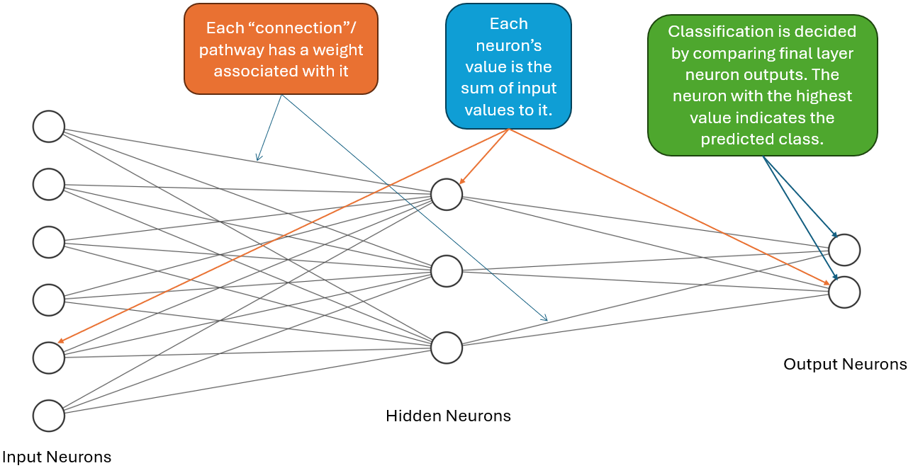
Unlike traditional programming, where tasks are completed through explicit instructions, neural networks learn from vast amounts of data. Through this learning process, they are able to identify patterns, make decisions, and predictions, thereby solving problems in a manner akin to human cognition. This capability has led to their widespread application in diverse fields such as finance, healthcare, image and speech recognition, and autonomous vehicles.

Architecture of Neural Networks
The architecture of a neural network is a structured representation of various layers and neurons within these layers, designed to process information sequentially.

Input Layer: Serving as the gateway into the neural network, the input layer consists of neurons corresponding to the dimensions or features of the input data. Each neuron in this layer represents a unique input feature, translating real-world data like images, sound, text, or numeric values into a format the network can understand.

Hidden Layers: Nested between the input and output layers are the hidden layers, where the majority of data processing occurs. Each layer consists of neurons that apply transformations to the inputs received from the previous layer. The number of hidden layers and the number of neurons in each hidden layer define the network's depth and width, respectively, and significantly impact the network’s capability to learn complex patterns. Typically, these neurons apply weighted sums on their inputs followed by non-linear activation functions, allowing the network to capture non-linear relationships.

Output Layer: The final layer in the network structure, the output layer, presents the network's predictions or decisions back to the external world. In classification tasks, each neuron corresponds to a potential class label, outputting probabilities reflecting the network's confidence. In regression tasks, neurons typically output continuous values corresponding to the predictions.
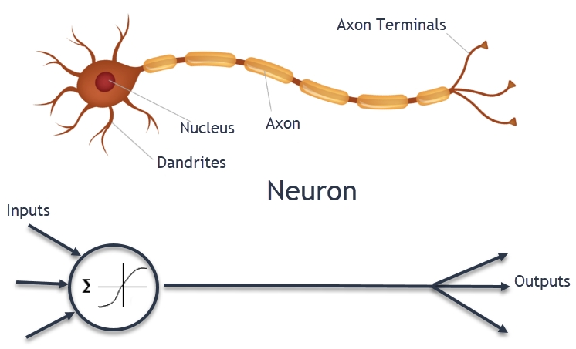
Neurons and Connections
Neurons, or nodes, are the basic operational units of a neural network, functioning similarly to biological neurons. Each neuron receives input from its predecessors, which it then processes using a weighted sum followed by an activation function. This mimics the dendritic input and synaptic strength of biological neurons:
- Weighted Sum: Each input to the neuron is multiplied by a corresponding weight, reflecting the importance or strength of the input in the neuron's final output. These weights are akin to the synaptic efficacy in biological neurons, modulating the signal strength as it passes between neurons.
- Activation Function: This function processes the weighted sum, introducing non-linearities into the network and enabling it to learn and model complex relationships. Without these functions, neural networks would be unable to capture the complexity and variability present in real-world data.
Each connection between neurons signifies the pathway for the data flow, with weights acting as filters that control the impact of inputs on the network's learning process. The architecture of connections, weights, and neurons defines how effectively a neural network can process and learn from data, making the understanding of these elements crucial for harnessing the full potential of neural networks in computational tasks.

Types of NNs - Regression
In regression in the context of Neural Networks, the goal is to predict continuous values. Neural networks for regression have one neuron per prediction target in the output layer and often use linear activation functions. Performance is usually measured by how close the network's predictions are to the actual values (using metrics like MSE).

Types of NNs - Classification
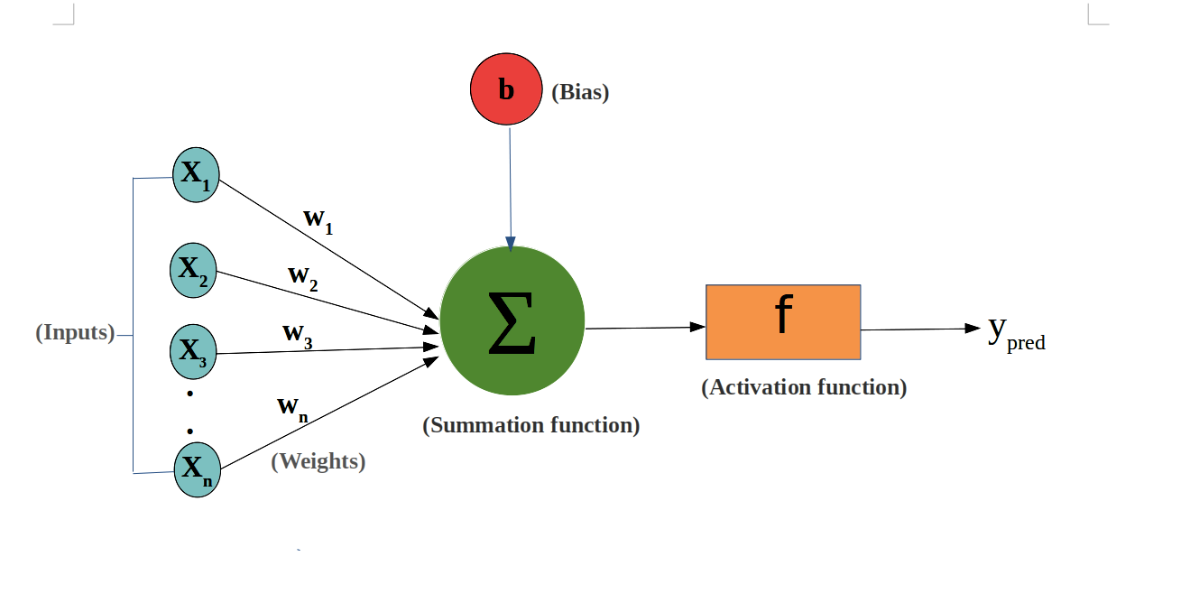
Classification involves assigning input data into different categories. The output layer of a classification network has one neuron per class (using softmax for multi-class problems) and aims to produce probabilities that the input belongs to each category. Performance is evaluated based on accuracy and other metrics like the confusion matrix and F1 score.

Understanding Weights and Bias
Weights determine the strength of the connection between neurons in different layers. During training, the network adjusts its weights to minimize the error in its predictions. Bias allows each neuron to shift its activation function to the left or right, which helps the network fit the training data more accurately.

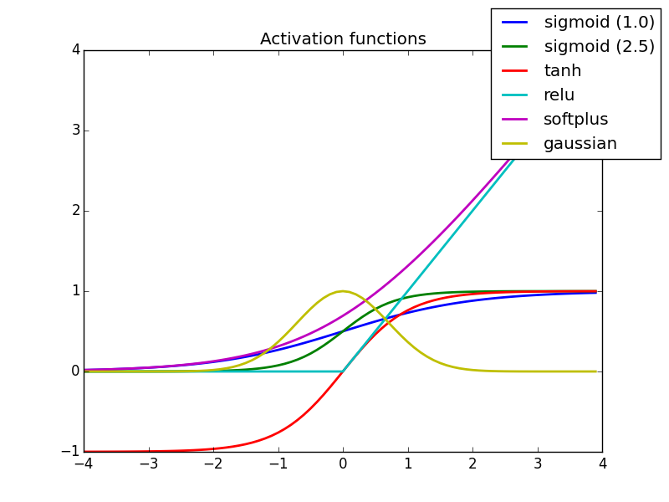
Activation Functions
Activation functions are mathematical equations applied to the weighted sum of inputs and a bias term at each neuron. They determine whether a neuron should be activated or not, influencing the neuron's output and, subsequently, whether and how much signal should be passed forward through the network.
Activation functions are critical because they help neural networks learn complex patterns through their non-linear properties. Without non-linearity, a neural network, regardless of how many layers it had, would still behave like a single-layer perceptron (a type of linear classifier), severely limiting its ability to solve complex problems.

Here are some common types of activation functions:
- Sigmoid: The sigmoid function outputs values between 0 and 1, making it particularly useful for binary classification problems. It has the mathematical form: $σ\left(x\right)=\frac{1}{1+e^{-x}}$. However, it is less used nowadays due to issues like vanishing gradients.
- Hyperbolic Tangent (Tanh): Similar to the sigmoid but outputs values between -1 and 1. It is mathematically represented as $\tanh\left(x\right)=\frac{e^{x}-e^{-x}}{e^{x}+e^{-x}}$. It's more symmetric around the origin, which can lead to better training performance for certain problems.
- Rectified Linear Unit (ReLU): Currently one of the most popular activation functions, defined as $f\left(x\right)=max\left(0,x\right)$. It introduces non-linearity while allowing for faster training without significantly diminishing gradient strength for large values of x.
- Leaky ReLU and Parametric ReLU (PReLU): Variants of ReLU designed to allow small, non-zero gradients when the unit is not active, solving the problem of "dying neurons" in ReLU (where neurons can stop learning entirely).
- Softmax: Often used in the output layer of classification networks, the softmax function converts raw output scores (logits) into probabilities by comparing the exponential for each output relative to the sum of exponentials for all outputs.
Non-linearity allows neural networks to make complex decisions. By applying a non-linear activation function, the network can combine simple patterns at lower layers to form more complex representations at higher layers. This capability enables neural networks to perform sophisticated tasks like image and speech recognition, where the relationships between inputs and outputs are not linear or straightforward.
The choice of activation function depends on the specific task and the characteristics of the input and output data. For example, ReLU and its variants are generally preferred for hidden layers due to their computational efficiency and effectiveness in mitigating the vanishing gradient problem. In contrast, softmax is preferred for multi-class classification tasks in the output layer due to its probabilistic interpretation.
Section 2: Training Neural Networks
Training neural networks is a systematic process aimed at enabling the network to predict or classify data accurately. This chapter delves into the mechanisms behind neural network training, covering fundamental concepts such as forward propagation, backpropagation, learning rate, and regularization in detail.

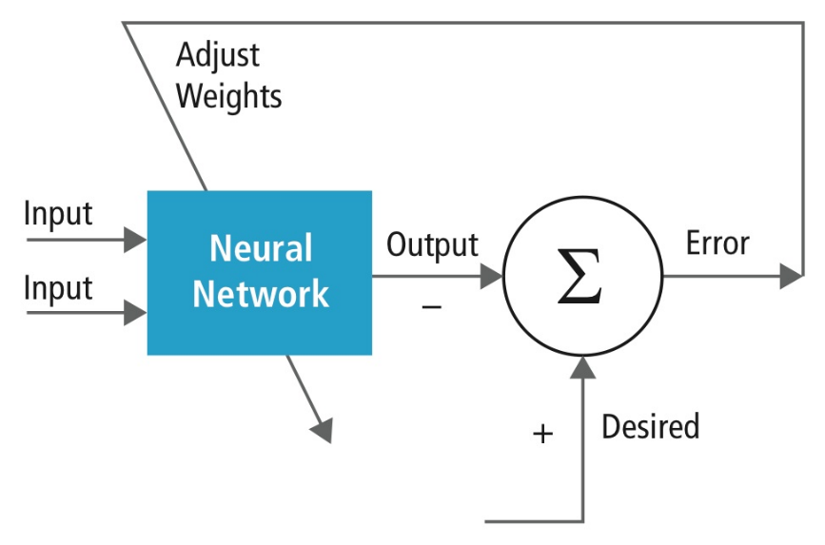
The Learning Process
The primary objective of neural network training is to find the optimal set of weights and biases that minimize the difference between the actual outputs and the predictions made by the network. This is typically achieved through a process known as learning, which involves adjusting these parameters based on the network's performance on a dataset.

Mathematical Representation of NN
The neural network can be mathematically represented as a series of functions, each corresponding to a layer in the network. For a simple network with one hidden layer, the output can be represented as:
$$y=f_{2}\left(w_{2}⋅f_{1}\left(w_{1}⋅x+b_{1}\right)+b_{2}\right)$$
where $x$ is the input, $w_{1}$and $w_{2}$ are the weights, $b_{1}$ and $b_{2}$ are the biases, $f_{1}$ and $f_{2}$ are the activation functions, and $y$ is the output.

Forward Propagation
Forward propagation is the process of passing inputs through the network to obtain an output. At each layer, the network applies weights to the inputs and adds biases (linear transformation) before applying an activation function (non-linear transformation).

For each layer $l$ , the pre-activation value $z^{\left(l\right)}$ and the activated value $a^{\left(l\right)}$ are computed as follows:
$$z^{\left(l\right)}=W^{\left(l\right)}a^{\left(l-1\right)}+b^{\left(l\right)}$$
$$a^{\left(l\right)}=f^{\left(l\right)}\left(z^{\left(l\right)}\right)$$
where $W^{\left(l\right)}$ and $b^{\left(l\right)}$ are the weights and biases of the layer $l$ , and $f^{\left(l\right)}$ is the activation function.

Loss and Backpropagation
After computing the output, the network assesses its accuracy using a loss function, which measures the difference between the predicted output and the actual target values.

[Loss function] Mean Squared Error (MSE) for regression:
$$MSE=\frac{1}{N}\sum_{i=1}^{N}{{\left(y_{i}-\hat{y_{i}}\right)}^{2}}$$
where $N$ is the number of samples, $y_{i}$ is the actual value, and $\hat{y_{i}}$ is the predicted value.

Backpropagation is then used to compute the gradient of the loss function with respect to each weight and bias in the network, effectively measuring how changes to these parameters affect the output error. REFER TO EXAMPLE #1 for details.
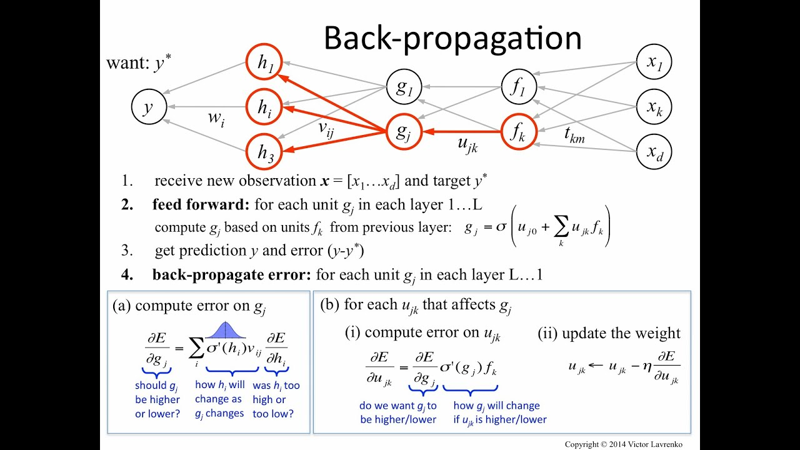
Gradient
The gradient of the loss with respect to the weights in layer $l$can be expressed as:
$$\frac{∂\text{Loss}}{∂W^{\left(l\right)}}=\frac{∂\text{Loss}}{∂a^{\left(l\right)}}⋅\frac{∂a^{\left(l\right)}}{∂z^{\left(l\right)}}⋅\frac{∂z^{\left(l\right)}}{∂W^{\left(l\right)}}$$
This gradient informs how to adjust the weights to reduce the loss, typically performed using a gradient descent optimization algorithm.

Optimization and Learning Rate
The learning rate $η$ is a crucial hyperparameter that influences the size of the steps taken towards minimizing the loss function. During the update, the weights are adjusted in the opposite direction of the gradient:
$$W_{new}^{\left(l\right)}=W_{old}^{\left(l\right)}-η\frac{∂\text{Loss}}{∂W^{\left(l\right)}}$$
Choosing an appropriate learning rate is vital as too large a rate can lead to overshooting the minimum, while too small a rate results in slow convergence.

Regularization
Regularization techniques are employed to prevent the model from overfitting, ensuring that the model generalizes well to unseen data. L1 and L2 regularizations are commonly used methods:

- L1 Regularization: Adds the absolute value of the weights to the loss function.
$${ Loss}_{new} ={ Loss}_{old} + λ∑|W|$$
- L2 Regularization: Adds the squared value of the weights to the loss function.
$${\text{Loss}}_{new}={\text{Loss}}_{old}+λ\sum{W^{2}}$$
where $λ$ is the regularization parameter.

Training Epochs and Batches
An epoch refers to one complete pass of the entire training dataset through the network. Neural networks usually require multiple epochs to learn effectively. Data can be divided into smaller batches to update the weights more frequently, enhancing the training speed and stability. This method is known as batch or mini-batch training.

Batch Training Example: The dataset is divided into batches of size $M$, and the network is updated after each batch:
$${\text{Loss}}_{batch}=\frac{1}{M}\sum_{i=1}^{M}{\text{Loss}\left(y_{i},\hat{y_{i}}\right)}$$

Section 3: Evaluating and Tuning Neural Networks
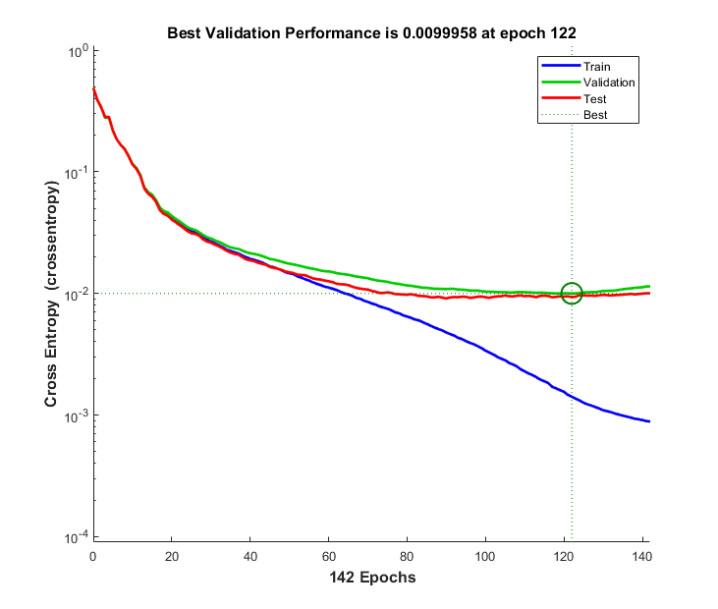
In the realm of machine learning, particularly within the context of neural networks, the evaluation and fine-tuning of models are pivotal for achieving optimal performance. This section delves into the methodologies and metrics essential for assessing neural networks, followed by strategies to refine and enhance their effectiveness.

Performance Metrics
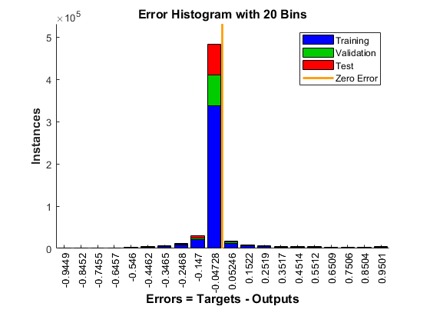
The cornerstone of evaluating a neural network lies in its performance metrics, which offer a quantifiable measure of the model's effectiveness. Accuracy, a fundamental metric, represents the proportion of correctly predicted observations to the total observations. While inherently intuitive, accuracy alone can be misleading, especially in imbalanced datasets where one class significantly outnumbers the other.

To counteract the limitations of accuracy, precision and recall emerge as critical metrics. Precision, the ratio of true positive predictions to the total positive predictions, assesses the model's exactness, whereas recall, or sensitivity, measures the model's ability to identify all relevant instances. The F1 Score, the harmonic mean of precision and recall, provides a balanced measure, especially useful when the cost of false negatives and false positives is high.
In regression tasks, the Mean Squared Error (MSE) is prevalent, quantifying the average squared difference between the estimated values and what is estimated. MSE offers a clear picture of the model's prediction accuracy, with a lower value indicating a better fit.

Visualizing Training Progress
The trajectory of neural network training can be intricate. Visualizations such as error histograms, training state graphs, and performance plots serve as navigational beacons. An error histogram, illustrating the distribution of prediction errors, aids in identifying biases and anomalies in model predictions.

The training state graph, depicting metrics such as gradient magnitude and validation checks over epochs, is instrumental for diagnosing model behavior over time. For instance, an escalating gradient might indicate an imminent divergence, whereas repetitive cycles in the error rate could signal an oscillation around a local minimum.
Furthermore, the training performance graph, plotting the performance metric over each epoch, unveils the learning trajectory, enabling the identification of overfitting instances, where the model performs well on the training data but poorly on unseen data.

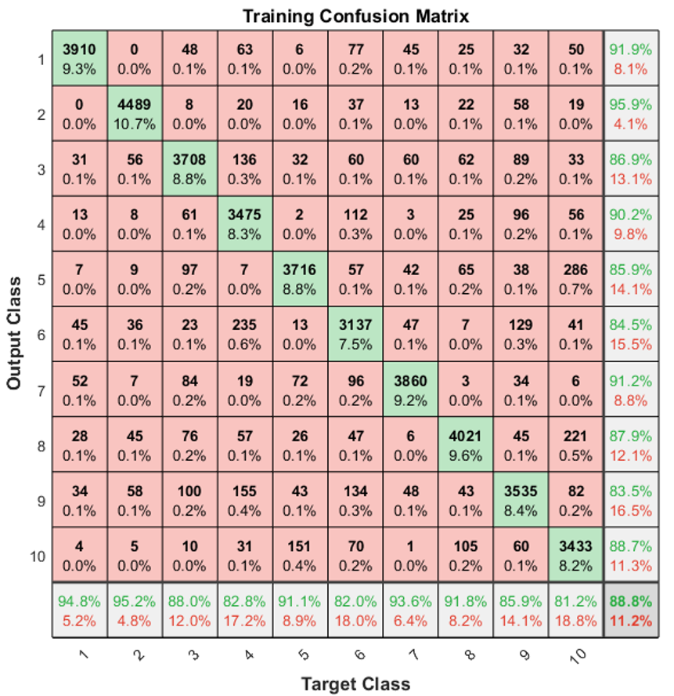
Confusion Matrix
A confusion matrix is a powerful tool used in machine learning to evaluate the performance of classification models. It is a table with two dimensions: "Actual" and "Predicted," each divided into the number of classes the model is designed to identify. For a binary classification problem, the matrix consists of four entries: True Positives (TP), False Positives (FP), True Negatives (TN), and False Negatives (FN).

  - True Positives (TP): Instances correctly predicted as positive.
  - False Positives (FP): Instances incorrectly predicted as positive.
  - True Negatives (TN): Instances correctly predicted as negative.
  - False Negatives (FN): Instances incorrectly predicted as negative.
The main diagonal (TP and TN) represents correct predictions, while the other entries (FP and FN) denote errors. The confusion matrix allows not only the calculation of performance metrics such as accuracy, precision, recall, and F1 score but also provides insights into the types of errors made by the classifier. This detailed breakdown helps in understanding the model's strengths and weaknesses, especially in imbalanced datasets where one class significantly outnumbers the other.

Receiver Operating Characteristic (ROC)
In binary classification tasks, the Receiver Operating Characteristic (ROC) curve is an indispensable tool. It plots the True Positive Rate (TPR) against the False Positive Rate (FPR) at various classification thresholds. The curve illustrates the trade-offs between sensitivity and specificity, providing insights into the model's discriminatory capacity at different thresholds.
The Area Under the Curve (AUC), associated with the ROC, offers a single measure reflecting the model's ability to distinguish between classes. An AUC of 1.0 signifies a perfect model, while an AUC closer to 0.5 suggests no discriminative power, akin to random guessing.
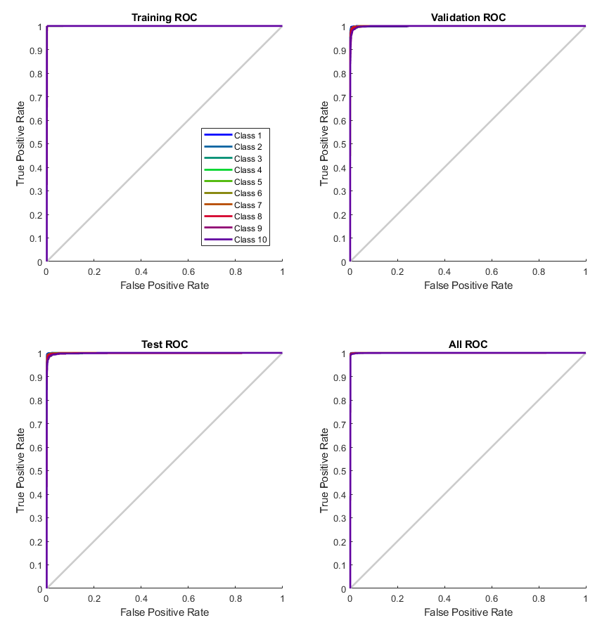

EXAMPLE #1: Back Propagation:
Imagine a very basic neural network that does not have hidden layers, only two input neurons, and a single output neuron. Also, for simplicity, let's assume that the neurons do not have bias terms. The system consists of two inputs (denoted as I1 and I2), two weights (denoted as W1 and W2), and one output (denoted as O).
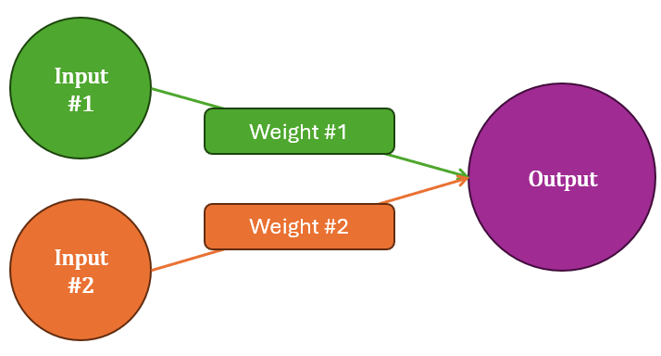
Let's go through one whole epoch with the basic neural network using the dataset. We’ll calculate the new weights after processing each data entry. Initially, we have:
- Initial weights: W1 = 0.1, W2 = 0.1
- Learning rate (α) = 0.5

Input #1 | Input #2 | True Output
0 | 0 | 0
0 | 1 | 0
1 | 0 | 1
1 | 1 | 1

Step 1: First Data Entry (0, 0) => 0
- Predicted Output (O) $= W_{1}* I_{1}+ W_{2}* I_{2}= 0.1 * 0 + 0.1 * 0 = 0$
- Error (E) $= ½ * {\left(T – O\right)}^{2}= ½ * {\left(0 – 0\right)}^{2}= 0$
- Update Weights: No update needed since error is 0.

Step 2: Second Data Entry (0, 1) => 0
- Predicted Output (O) $= 0.1 * 0 + 0.1 * 1 = 0.1$
- Error (E) = $½ * {\left(0 – 0.1\right)}^{2}$= 0.005
- Gradient for W1: $\frac{dE}{dW1}= \left(O – T_{rue}\right)* I_{1} = \left(0.1 – 0\right)* 0 = 0$
- Gradient for W2: $\frac{dE}{dW2}= \left(O – T_{rue}\right)* I_{2} = \left(0.1 – 0\right)* 1 = 0.1$
- Update Weights:
  - $W1_{new}= W1 - α *\frac{dE}{dW1}= 0.1 - 0.5 * 0 = 0.1$
  - $W2_{new}= W2 - α *\frac{dE}{dW2}= 0.1 - 0.5 * 0.1 = 0.05$

Step 3: Third Data Entry (1, 0) => 1
- Predicted Output (O) $= 0.1 * 1 + 0.05 * 0 = 0.1$
- Error (E) = $½ * {\left(1 – 0.1\right)}^{2}= 0.405$
- Gradient for W1: $\frac{dE}{dW1}= \left(O – T_{rue}\right)* I_{1}= \left(0.1 – 1\right)* 1 = -0.9$
- Gradient for W2: $\frac{dE}{dW2}= \left(O – T_{rue}\right)* I_{2}= \left(0.1 – 1\right)* 0 = 0$
- Update Weights:
  - $W1_{new}= W1 - α *\frac{dE}{dW1}= 0.1 - 0.5 * \left(-0.9\right)= 0.55$
  - $W2_{new}= W2 = 0.05$ (no change since gradient is 0)

Step 4: Fourth Data Entry (1, 1) => 1
- Predicted Output (O) = $0.55 * 1 + 0.05 * 1 = 0.6$
- Error (E) = $½ * {\left(1 – 0.6\right)}^{2}= 0.08$
- Gradient for W1: $\frac{dE}{dW1}= \left(O – T_{rue}\right)* I_{1}= \left(0.6 – 1\right)* 1 = -0.4$
- Gradient for W2: $\frac{dE}{dW2}= \left(O – T_{rue}\right)* I_{2}= \left(0.6 – 1\right)* 1 = -0.4$
- Update Weights:
  - $W1_{new}= W1 - α *\frac{dE}{dW1}= 0.55 - 0.5 * \left(-0.4\right)= 0.75$
  - $W2_{new}= W2 - α *\frac{dE}{dW2}= 0.05 - 0.5 * \left(-0.4\right)= 0.25$

After processing all four entries (one epoch), the updated weights are:
- W1 = 0.75
- W2 = 0.25

These new weights would then be used at the start of the next epoch, and the process would repeat until the weights converge or meet a predefined criterion (such as a maximum number of epochs or a minimum error threshold).

Exercise 1-4: Using MATLAB to load ML models from GitHub
Your objective is to download the 4 exercises from GitHub using the code below and train models.
- Multi-variate polynomial regression for housing prices
- Decision Trees and Random Forests for Text Sentience
- FNN for Digit classification
- CNN for image classification
In MATLAB, you will navigate to the correct directories and run the associated exercise after running the following code.

Writing the Code:
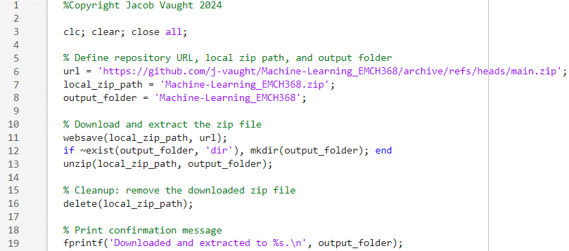

Exercises are in the following Directories.
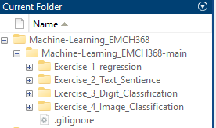S

Lab Grading Rubric:
- Exercise 4 fully functioning (10 points)
- Exercise 3 fully functioning (10 points)
- Exercise 2 fully functioning (5 points)
- Exercise 1 fully functioning (5 points)
- Understanding of material (20 points)

